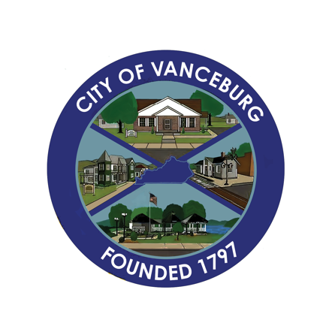
PRESS RELEASE
CITY OF VANCEBURG
189 Second Street, Vanceburg, KY 41179 | 606-796-3044
Email: Marketing@cityofvanceburg.com

October 29
Community Accelerator
From: Brenda S. Bear, City of Vanceburg



The City of Vanceburg has been accepted to the What’s Next EKY Community Accelerator Program for 2024-2025. The Community Accelerator program is designed to help under-resourced communities in the 54 Appalachian counties of Eastern Kentucky accelerate their local economy by organizing a diverse team to leverage local assets, creatively overcome challenges, and improve the quality of life for residents. The program is designed to be flexible and community-led, with What’s Next EKY?! offering resources and support along each community’s accelerator journey.

Since the program was started in 2021, four communities have participated. Pikeville, Kentucky in 2021, Grayson, Kentucky began in 2022 while Jackson County and Letcher County, Kentucky, joined in 2023.

Mayor Blankenship is collaborating with County Judge Executive George Sparks and a dedicated group of community leaders. Their first meeting is scheduled for November 14 in Berea. We’re thrilled to have such a committed team on board to help ensure the success of this program, and we look forward to sharing updates and project developments as we progress.

